**Online Library**

**Team members:** Gulkhayokhon Tulasheva (u1610074)

Nasibakhon Elchieva (u1610164)

**ONLINE LIBRARY**

The library.uz the web page where users can download the book which they like. They also can search a book by their name and can download if the book is existed. The web page is very easy to understand. There are all book types in the left side and it helps user easily to find book by types. Also user can read a short information about book. Admin can add book and book type to the web page.

**Structure of our web page.**

Online library

All books

Admin

About

Home

Search

Information about web page

Search book

Add book

New books

Books and download

Add type

Books

Figure 1. Structure of web page

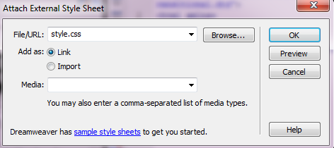

Figure 2. Connecting PHP with CSS

Style.css is our CSS document. Here if we press the button OK the PHP and CSS documents will be connected. We can check it by writing the <link href="style.css" rel="stylesheet" type="text/css" /> between the tags <head> </head> of PHP document.

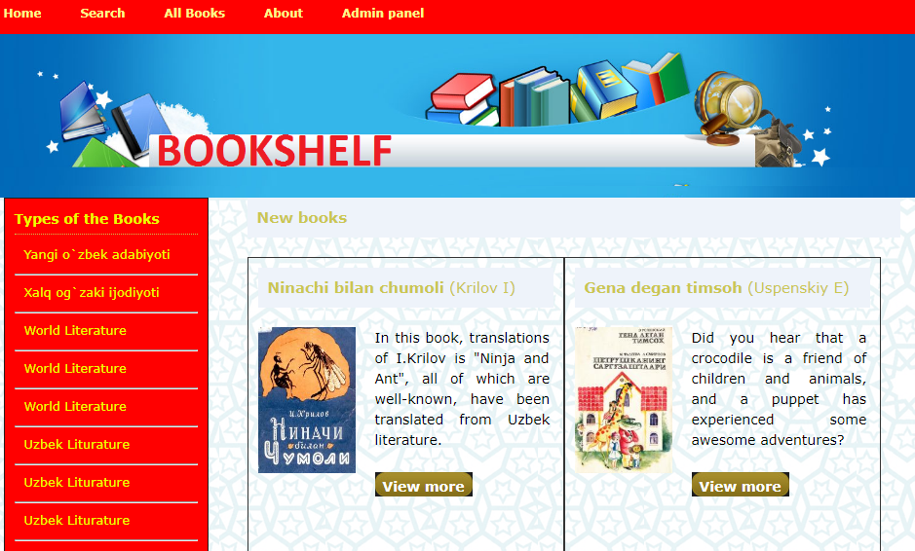

Figure 3. Appearance of home page

After creating the Home page we set other pages too. In the navigation part we created PHP pages. We added information and other things after adding tags and HTML codes and we checked.

**Admin page**

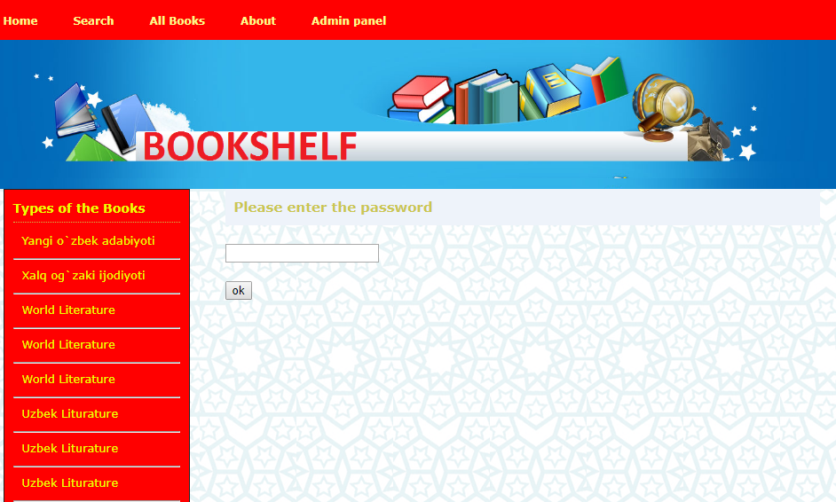

Figure 4. Admin page

This is our admin page. You need to enter password. The password is 1997.

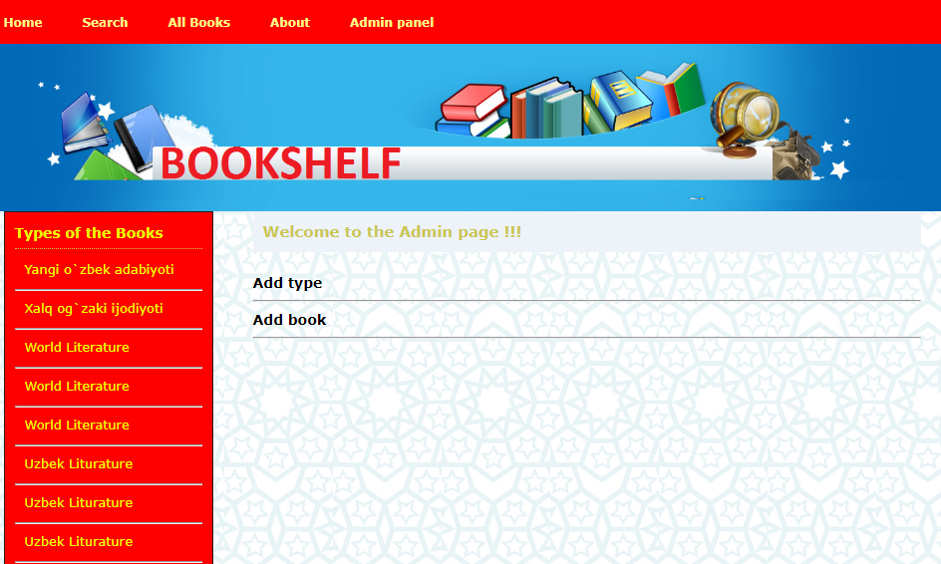

Figure 5. Admin panel

After entering the password, this page will be seen. As you see in this page admin can add new type of book and new book too.

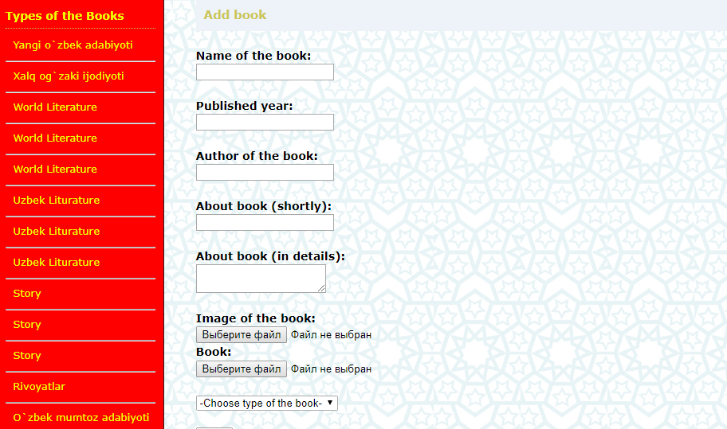

Figure 6. Add book page

As you see for saving new book you need to fill all fields. If any of them will not be filled the error message will appear.

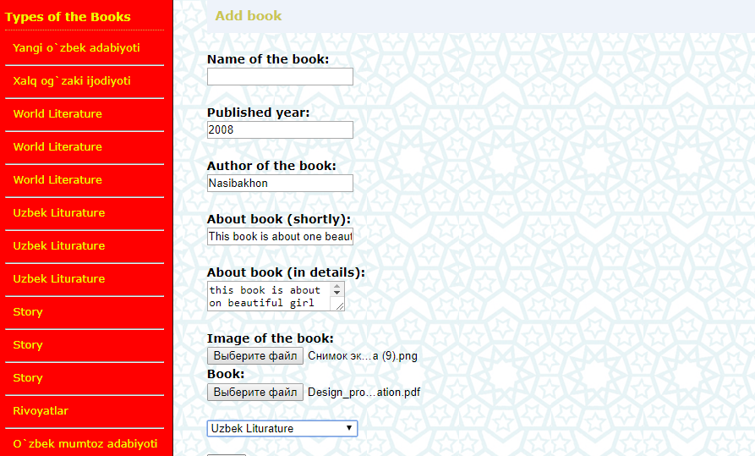

Figure 7. Add book page

Here you can see that I did not enter the name of the book.

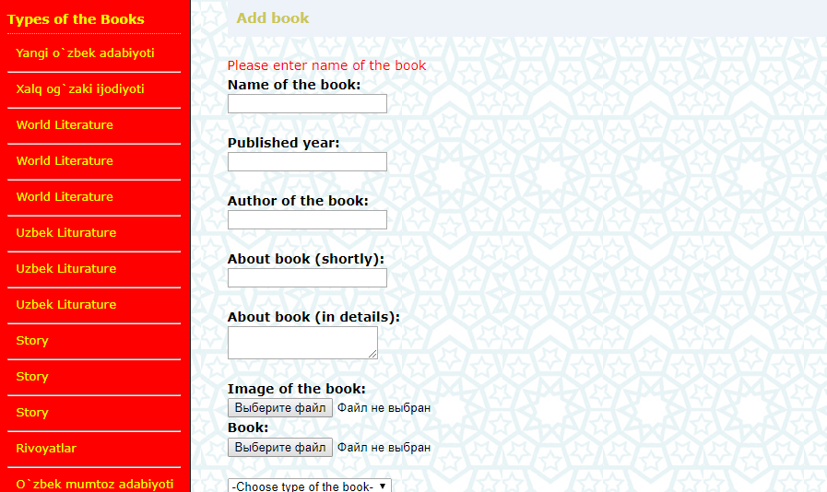

Figure 8. Add book page

And after pressing the button save this message will appear.

**Search page**

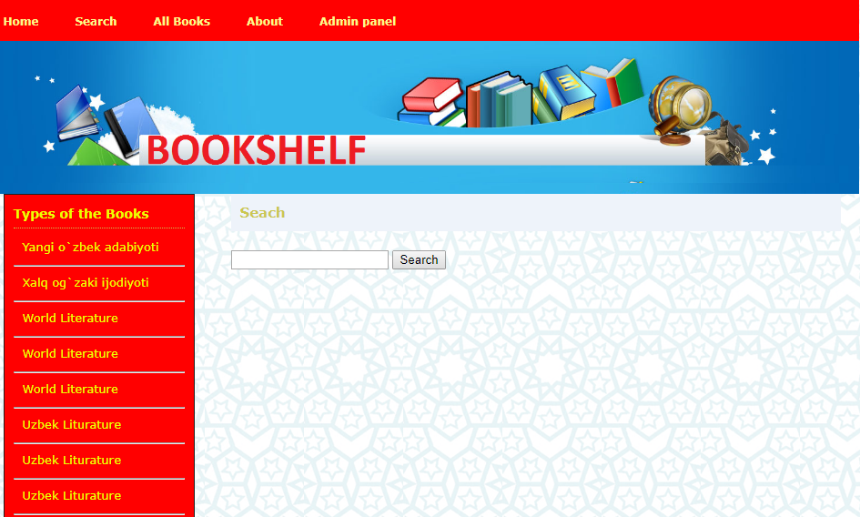

Figure 9. Search page

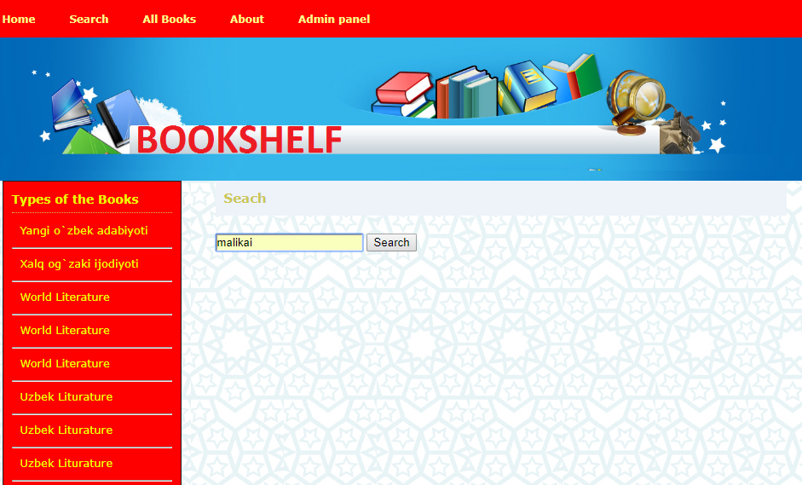

Figure 10. Search page

Here I input the name of the book which I want to find.

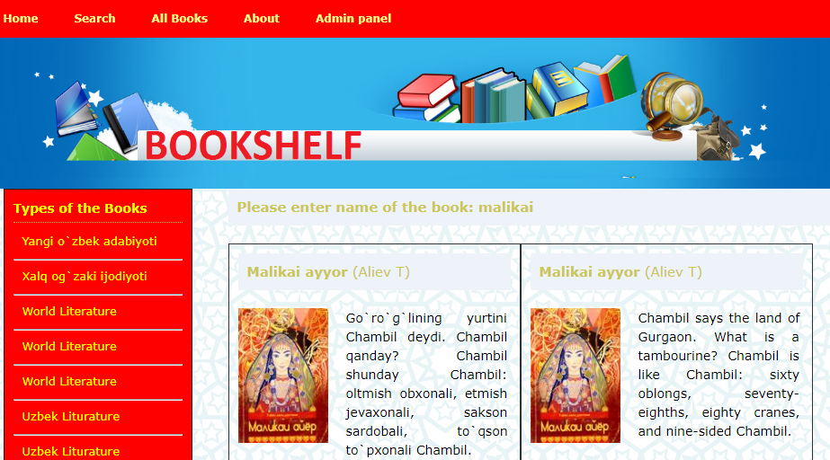

Figure 11. Search page

And after pressing the search button the book will be find.

**ABOUT PAGE**

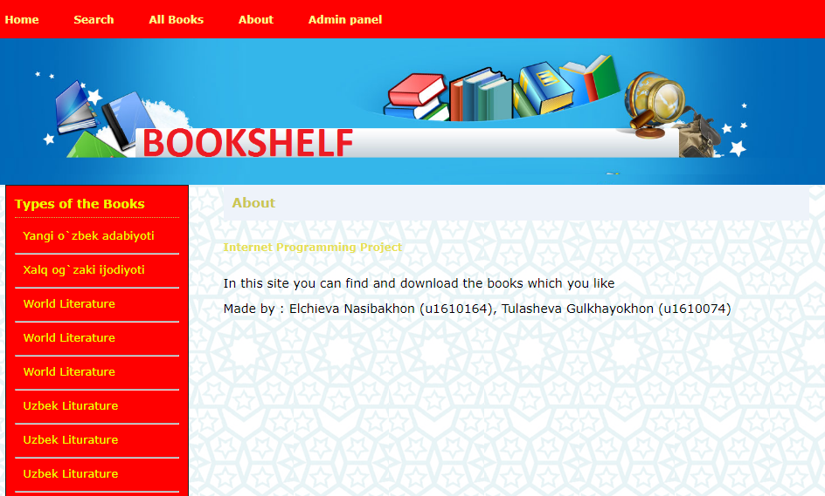

Figure 12. About page

In this page users can read all about us.

**ALL BOOKS PAGE**



Figure 13. All books page

In this page user can see all book which are unsorted and read short information.

**URL Links to our remotely hosted web site and GitHub repository**

<https://github.com/iuthub/design-project-twin-2>

**References**

1. Денис Колисниченко “PHP и MySQL. Разработка Web-приложений”
2. Николай Прохоренок “HTML, JavaScript, PHP и MySQL. Джентльменский набор Web-мастера”
3. <http://htmlbook.ru>
4. <http://www.Bootstrap.com>
5. http://Code.org/jquery/styles
6. <http://php.net>
7. http://w3schools.com